Dear PPG Members,
You’re invited to join a session to learn more about the NHS App – what it does, how it can help patients, and how you can support others in your practice and the wider community to use it.
The NHS App is becoming an important way for patients to access health services – from ordering prescriptions and viewing test results, to managing appointments and seeing their medical records. But it can sometimes feel confusing, especially when systems and processes vary at different GP practices.
This session will cover:
- What the NHS App is and what it can do
- How it links with your GP practice
- Common problems people face (and how to fix them)
- How to support others who might struggle with technology
The session will be led by Emma Delany, who works with both the NHS and the voluntary sector to help patients and practices across Derbyshire get the most from digital health tools like the NHS App. Emma and her team of volunteers have supported many people of all ages and abilities to feel more confident using these tools.
Session Details:
- Tuesday 29th July 2025
- 12:30pm-2:00pm
- Via Teams:
Microsoft Teams Need help?
Join the meeting now
Meeting ID: 310 179 913 201 1
Passcode: X4vZ2UX9
Everyone is welcome – whether you use the app already or are completely new to it!
If you have any questions or need help joining the session, please don’t hesitate to get in touch.
Kind regards,
Emma Delany
Emma Delany
(she/her)
Digital Health Lead
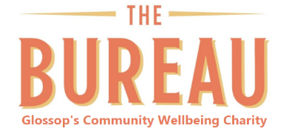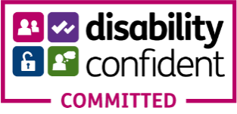
Phone: 01457 865722 Mobile: 07920 170126
Email: emma@the-bureau.org.uk
NHS Email: emma.delany@nhs.net
Website: www.the-bureau.org.uk
Bank House, 22 Henry Street, Glossop, Derbyshire SK13 8BW

